**EXPERIMENT NUMBER: 3**

**Student Name: Lagan Verma UID:20BCS3515**

**Branch: Information Security Section/Group: 20BIS1/A**

**Semester: 5th Date of Performance: 18.08.2022**

**Subject Name: Network Defense Essentials Lab Subject Code: 20CSB-331**

**1. Aim/Overview of the practical:**

Implementing password policy using windows gpu.

**2. Task to be done:**

Provide the different security rules which are applicable to each and every new PC user created.

**3. Steps for experiment/practical:**

1.Install the local security policy , and then open the page.

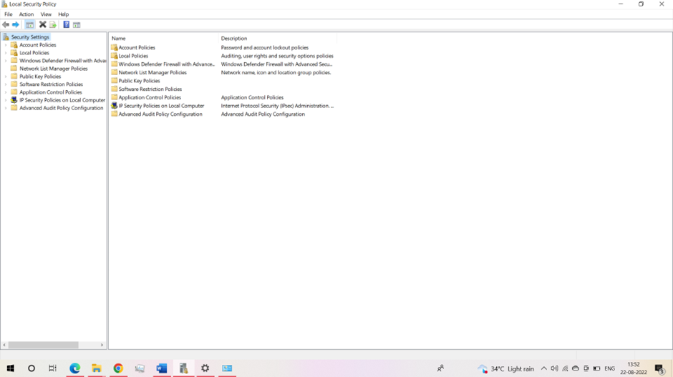

2. Select the option Account Policies and then from drop-down go to Password Policy.

Enter the minimum length of the password which will be applicable to each and every Pc user.(here:4 characters)

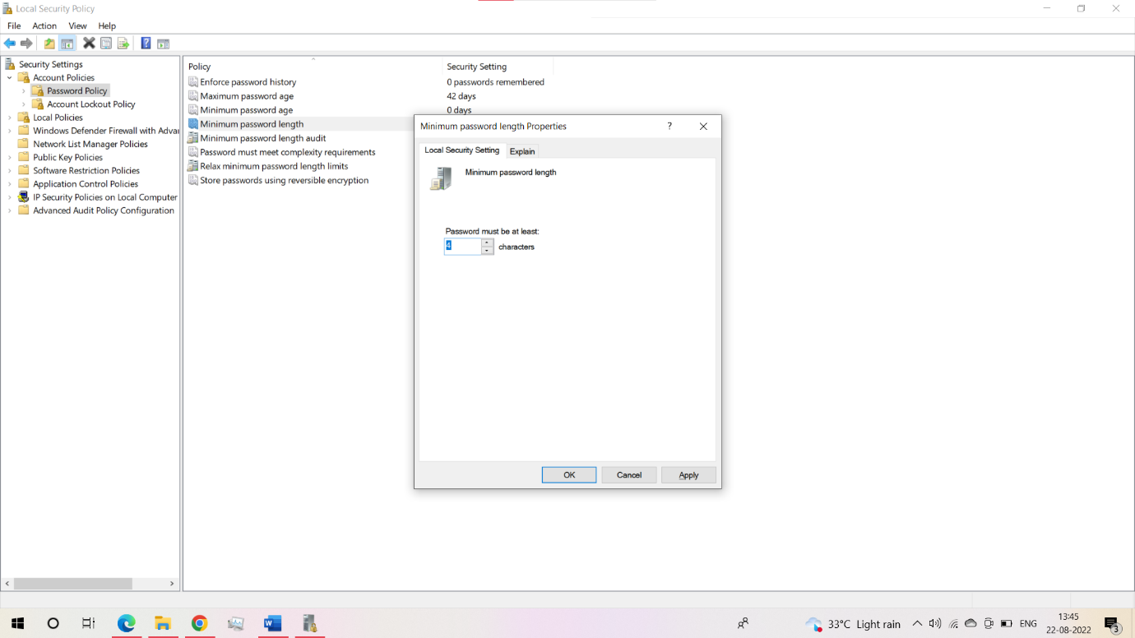

3.Go to the Control Panel, and select the Family & other users. Select the other option .(here: we don’t have to provide any email address and mobile number)

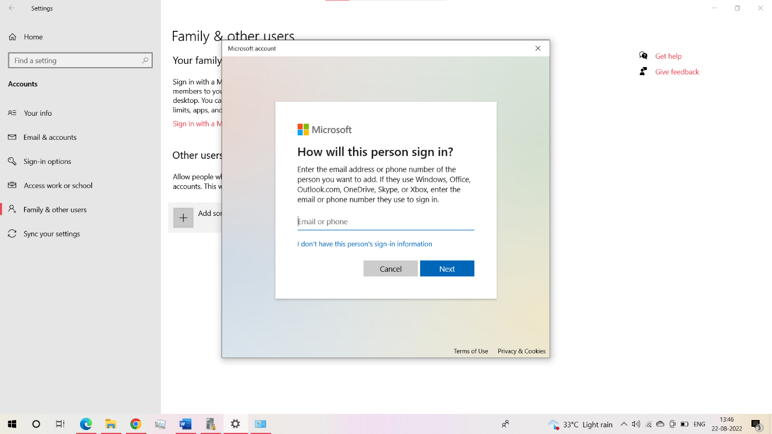

4.Set the password and assign only 3 characters. It will generate the error as the password policy set is of minimum 4 characters.

Here the user will not created as the password given does not match the criteria .

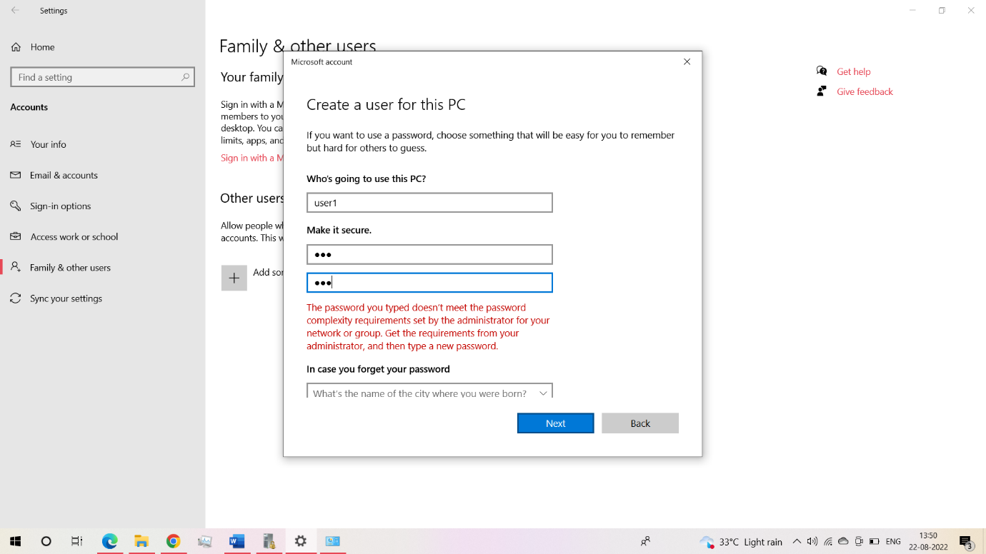

**Learning outcomes (What I have learnt):**

1. Learnt about the various password policies.

2.Implemented the concept to set any password criteria which is applicable to every users

Evaluation Grid (Created as per the Assessment Model):

|  |  |  |  |
| --- | --- | --- | --- |
| Sr. No. | Parameters | Marks Obtained | Maximum Marks |
| 1. | Worksheet completion |  | 8 |
| 2. | Conduct of Experiment |  | 12 |
| 3. | Quiz/Viva Voce |  | 10 |
|  | Total |  | 30 |